Lecture 6

**AWS-Elastic-IP-S3**

To update $ yum check-update à it downloads from Amazon repository.

* if a certain app do not work
* Updates can be rolled back as we have done previously $ yum history undo <ID>

**Elastic -IP**

Public IP/live IP

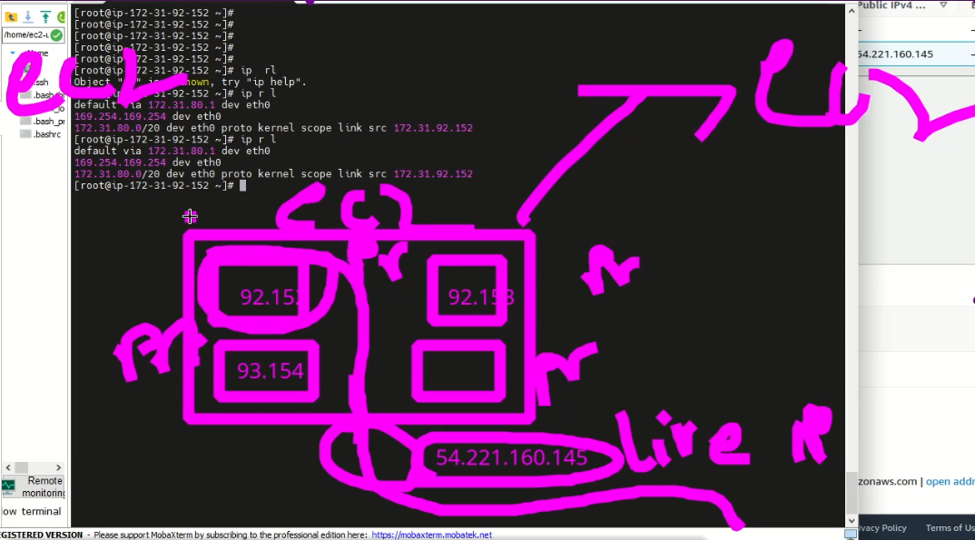

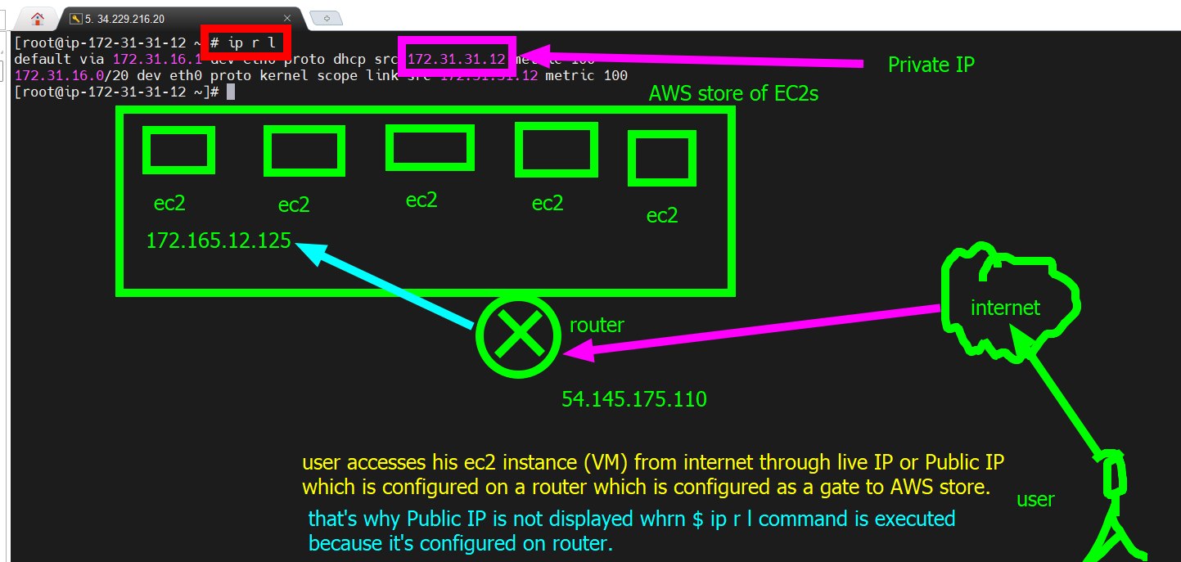

* The router NATs and takes the request to the specific ec2 instance.
  + **NAT** stands for Network Address Translation. It is a process used by routers to allow multiple devices on a private network to share a single public IP address. NAT operates by translating the IP addresses of devices on the private network to the public IP address of the router, and vice versa, when data is transmitted over the internet.
* 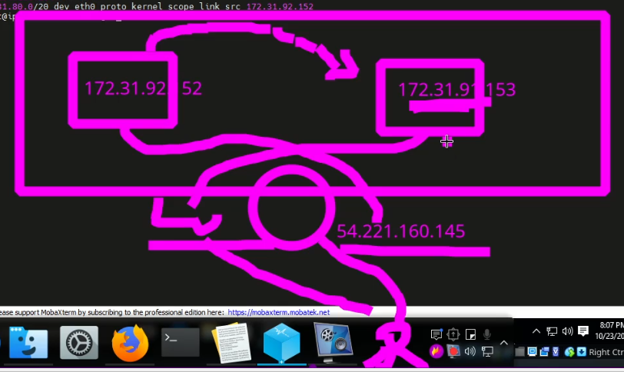
* .
* To check our Live IP
* **$ curl ifconfig.me** 🡪 to show Live IP
* 
* 🡪 on CentsOS 7 VM
* It is configured on my router (TendaWIFI)
* 🡪 another command to display live IP
* **Why live IP changes every time we reboot EC2?**
* When you launch an EC2 instance, it is assigned a private IP address and a public IP address (if it's launched in a public subnet). The public IP address is used to communicate with the internet, and it's assigned dynamically from Amazon's pool of public IPv4 addresses.
* The reason why the public IP address changes every time you stop and start your instance (i.e., rebooting it) is that the address is dynamically assigned. When you stop your instance, the public IP address is released back to Amazon's pool of addresses. When you start the instance again, it is assigned a new public IP address from the pool.
* If you need a static IP address that doesn't change every time you stop and start your instance, you can allocate an Elastic IP address and associate it with your instance. Elastic IP addresses are static, persistent public IP addresses that you can associate with your instance, and you can reassign them to other instances as needed.
* **Elastic IP is provided with charges in AWS**
* 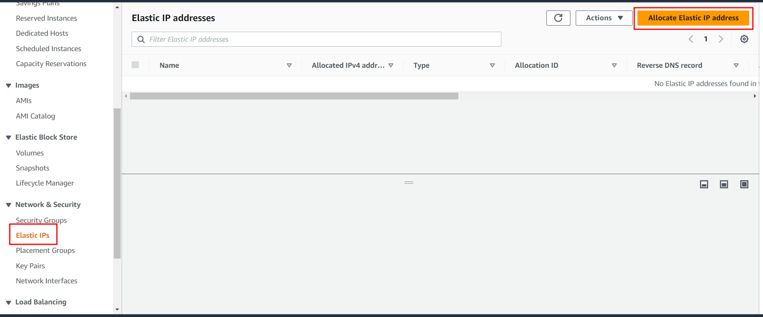
* 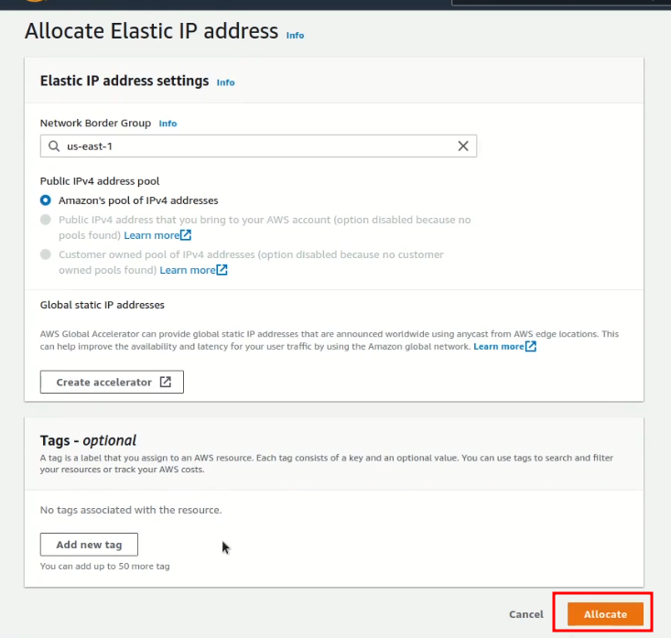
* 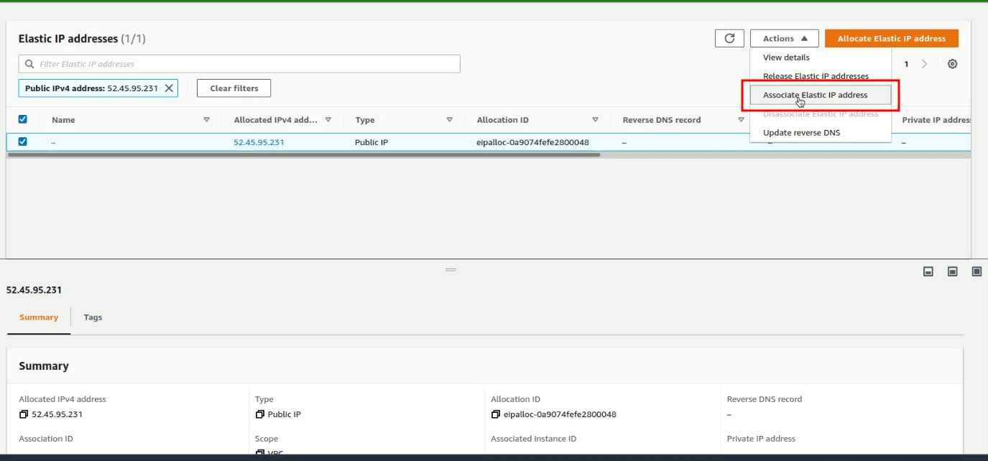 Graphical user interface, text, application

  Description automatically generated
* 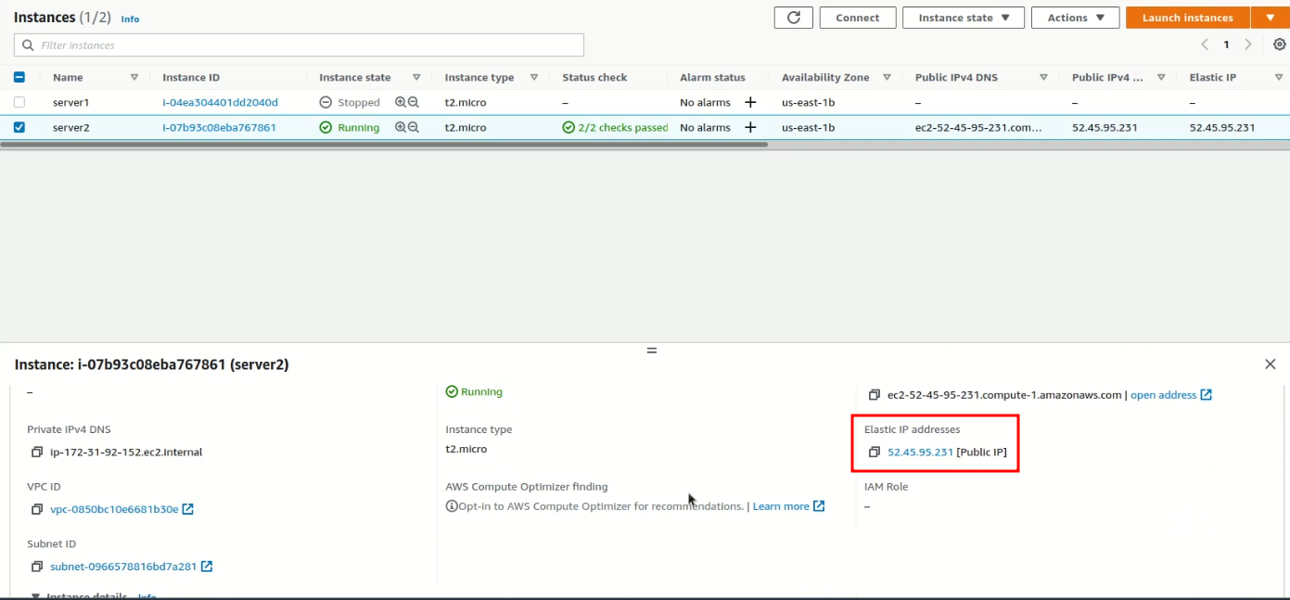
* If Elastic IP id disassociated
* 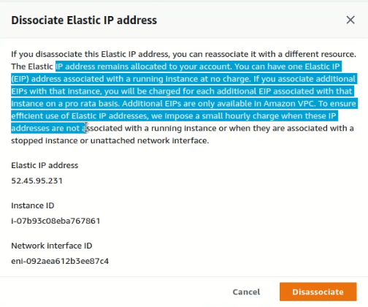
* The release it
* 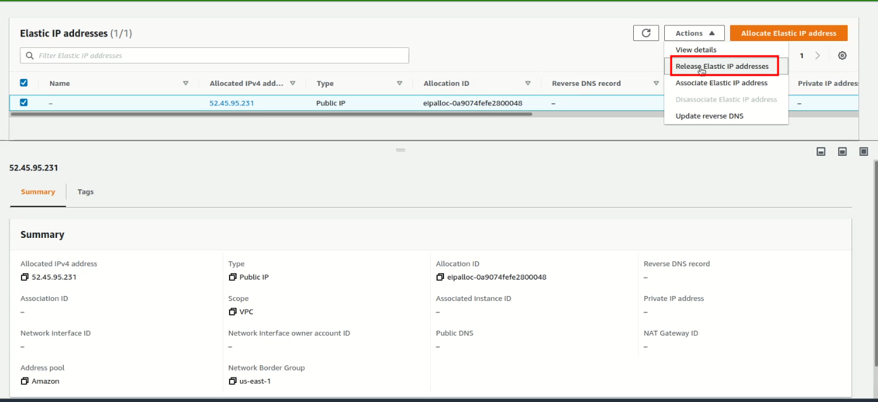
* 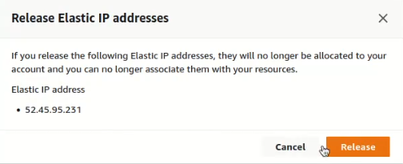

**S3 (Simple Storage Service)**

* Onedrive
* Google drive
* Dropbox
* Mega
* Terabox
* AWS provides 5Gb free S3
* EBS is volume and attached with EC2 🡪 not to be confused with S3.
* 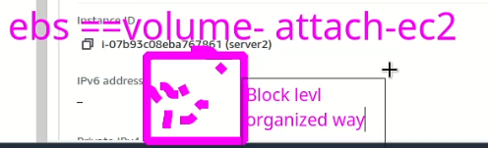
* S3 is not attached and can be accessed from anywhere.
* Data saved in S3 is unstructured and it is called object
* .
* Amazon S3 (Simple Storage Service) is a cloud-based object storage service offered by Amazon Web Services (AWS). It provides a simple and scalable storage solution for data in the cloud, which can be accessed and managed from anywhere using APIs, web interfaces, or third-party tools.
* S3 allows users to store and retrieve any amount of data, at any time, from anywhere on the web. The service offers high durability, availability, and security for your data, and it can be used for various purposes such as backup and restore, content distribution, big data analytics, and archival.
* S3 stores data as objects in buckets, which are logical containers for objects. Objects can be files, images, videos, or any other type of data, and they can be up to 5 terabytes in size. S3 offers a variety of storage classes, each with different performance characteristics and pricing options, to meet different use cases and needs.
* S3 also provides features such as versioning, lifecycle policies, cross-region replication, and encryption to help users manage and secure their data. It integrates with other AWS services and third-party tools to provide a complete storage and data management solution in the cloud.

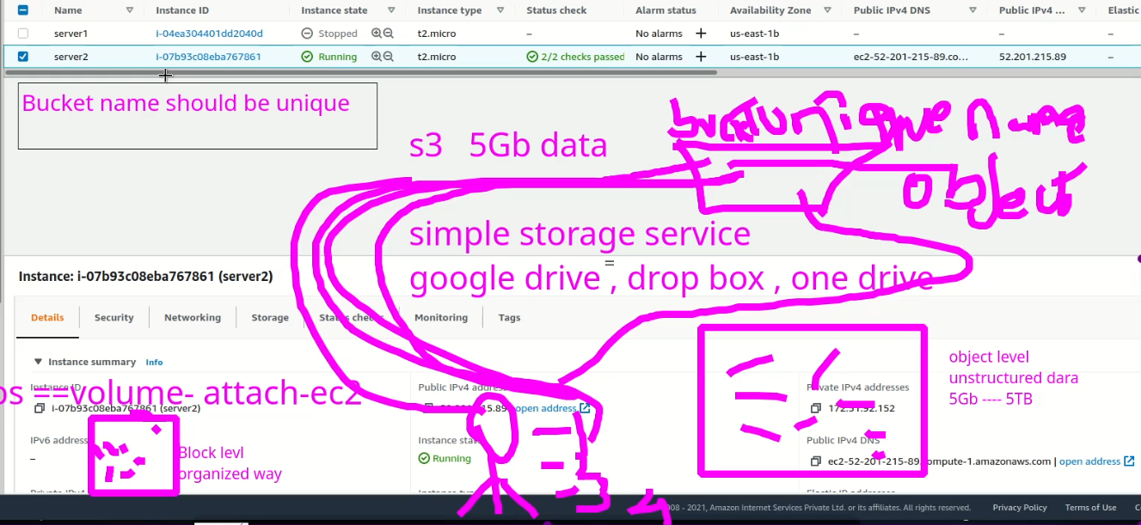

* Try accessing the bucket (Task)